Memorandum

|  |  |
| --- | --- |
| To: | City of Sparks |
| From: | Economic & Planning Systems |
| Subject: | Fiscal Impact Analysis Guidelines |
| Date: | July 29, 2019 |

Purpose of the Guidelines

The City of Spark requires fiscal impact analysis for certain development approval applications (see below). This memorandum provides guidelines for applicants for methodology and factors to utilize in preparation of a fiscal impact analysis. The purpose of the guidelines is for the City of Sparks to receive consistent information regarding the impact of development projects and to provide for a more streamlined, consistent approach for use of fiscal impact analysis findings when development approvals are reviewed by city staff, Planning Commission and City Council.

Applicability

A fiscal impact analysis is required for submittals that can potentially impact the future fiscal health of the City of Sparks. The following development approvals require a fiscal impact analysis according to the City of Sparks Master Plan policies:

* **Policy MG5:** When reviewing master plan amendments for sites over five acres, the City will evaluate or cause to be evaluated: a) the impacts on existing and planned public facilities and infrastructure; b) the impacts on existing and planned public services; c) the proposed land use in relationship to existing land uses; and, d) the fiscal implications for public service providers of the proposed land use changes as documented in a fiscal impact analysis.

**Policy MG7:** When reviewing annexation requests, the City will consider whether the proposed annexation: a) is included in the City’s Seven Year Annexation Program; b) is needed for the City’s growth within seven years; c) represents a logical extension of city limits; d) allows for efficient and cost effective provision of public services and capital facilities; and e) would be fiscally positive for a period of at least 20 years. When reviewing land use entitlements (e.g., master plan amendments, zone changes, tentative maps, conditional use permits) for land annexed within the previous 10-year period, the City may require an updated fiscal analysis if the proposed development materially varies from the development contemplated in the fiscal analysis prepared for the annexation.

* **Policy MG8**: When identifying lands for expansion of the City’s Sphere of Influence, the City must determine that the proposed expansion: a) represents a logical expansion of the City’s Sphere of Influence; b) is located within the Truckee Meadows Service Area (TMSA) as identified in the Truckee Meadows Regional Plan, or could reasonably be added to the TMSA; c) could be efficiently and cost effectively provided capital facilities and public services. The City’s determination will be based on preliminary infrastructure and facilities plans and a fiscal analysis addressing the cost of providing city services.
* **Policy EV10**: Require, prior to or with applications for land-use approvals (Tentative Map, Administrative Review or Conditional Use Permit), all development projects on green-field sites of 20 or more acres to demonstrate they are fiscally positive to the City for a period of at least 20 years.

# Fiscal Analysis Methodology

The purpose of fiscal impact analysis is to provide an objective estimate of the cost and revenue impacts to the City associated with new development. The analysis compares the estimated revenues generated by new development to the estimated costs of public services required to serve the development to determine the net fiscal impact. The fiscal impact analysis should separately analyze impacts to the City of Sparks’ General Fund and Road Fund. These funds are directly impacted by new development and are not cost recovery funds where fees for services are tied to cost to provide services.

Revenues and costs are estimated based on the budgets for each fund and department, and an assessment of potential effects of different types of development on each department or budget category. Certain revenue items are estimated using “case study” approaches based on formulas; for example, property tax is based on estimated assessed values multiplied by the applicable tax rates. Other items, such as public service costs related to residential development, are based on average cost factors (such as “per capita” estimate). The revenue sources and expenditures that have the largest impact on the budget and are most directly tied to growth have a specific case study developed for them, while other revenues and expenditures are estimated using average cost factors.

## Average Cost Nexus Factor

Nexus factors were developed that relate the specific budget item being estimated to the service population or other metric that is best associated with the impact. The nexus factors and approach to calculation are described below.

* **Peak Persons Served (Residents and Employees) Approach –** Many services are affected by growth in both residents and employees. For the majority of estimated costs and some revenues, a peak persons served factor is used. The purpose of this factor is to derive a peak population of persons served within the City. The number of people each type of land use generates is estimated using an average person generation factor (average residents per household for single family and multifamily, and the average number of employees per square foot for retail, office, industrial, hospitality). Using the persons served approach means each type of use will generate a number of people (e.g., one new single-family housing unit will generate 2.5 people) which will be used to estimate costs and revenues based on an average per person. This approach accounts for the proportion of employees that have historically lived and worked in the City in order to avoid double counting the impact of resident employees.
* **Per Unit Factors –** For both residential and non-residential uses, the majority of cost and revenue factors have been converted to a “per unit” of residential development factor based on averages for residents per unit and a “per square foot” of development based on the estimate number of employees per square foot. Non-residential development impacts are measured using a unit factor of 1,000 square feet of commercial/industrial space per unit, while residential uses utilize a per unit factor. The following factors were used to estimate impact, shown in **Table 1.**

Table 1

Per Unit and Square Foot Population Generation Factors



* **Pavement Square Feet and Linear Feet of Roadway –** Impacts to the Road Fund are estimated on the basis of the amount of new pavement/roadway (defined as areas between curbs) and the number of linear feet of roadway that the City of Sparks must maintain. The City maintains local and collector roads and, as a result, a new development’s impact will be evaluated based on the amount of pavement needed to serve the development and the estimated annual average cost per square foot of roadway to maintain the road over a 20 year period.

## Fixed and Variable Cost Adjustments

Directly applying the factors described above to new growth would be equivalent to using the average cost for each item, which can overstate cost impacts. For local governments whose services are at or near capacity, the average cost method is a generally accepted technique for estimating fiscal impacts. However, many functions still need to be adjusted to account for higher levels of fixed cost and/or a less direct relation to growth. The following process and assumptions were used in developing the “Percent Variable” adjustments to average costs.

* **Administrative and General Government** – Departments such as the City Manager, Mayor, City Council, Administrative, Legal, Municipal Court, Finance, and other management functions have a high level of fixed costs regardless of the size of a City. Costs in these types of departments and functions are estimated to be 25 percent variable (i.e. 25 percent of the cost can be attributed to new development).
* **Growth Impacted Departments –** These include departments such as Police, Fire, and Community Services. These types of services are much more closely related to growth and increased population and are modeled using the average cost methodology (100 percent variable).
* **Functions with No Nexus or Relevance –** Some City functions were determined not to have any relationship to real estate development projects (0 percent variable).

# Fiscal Impact Analysis Approach

The needed inputs and recommended approach for developing a fiscal impact analysis is described below.

Required Model Inputs

The data model inputs need to complete the fiscal model should be clearly defined and documented. The following data points are needed complete the fiscal impact analysis:

* Project size (land acres)
* Total and to-be-developed
* Acres by Use (single family, attached, mixed use, multifamily, retail, office, industrial, etc.)
* Proposed land uses and development
* Total number of residential units by type (single family, attached, multifamily)
* Total number of non-residential square feet (by type; retail, office, industrial, flex, hospitality)
* Square feet of roadway (pavement) and the linear feet of streets that will be maintained by the City of Sparks (local roads).
* Market value and development absorption
* Estimate market value per housing type (single family, attached, multifamily) used to estimate property tax generation
* Number of years estimated for build-out and estimated annual absorption (# of units) of proposed housing by type (single family, attached, multifamily)
* Estimated market value for each 1,000 square feet of non-residential space (retail, office, industrial, flex, hospitality) used to estimate property tax generation
* Number of years estimated for build-out and estimated annual absorption (square feet) of proposed non-residential space by use.

Analysis Timeframe

The analysis should utilize a 20 year time frame for estimating impact with Year 1 as the first year for development projected to have received a Certificate of Occupancy. The annual net fiscal impact and cumulative impact over 20 years should be documented for both the General Fund and the Road Fund. Any development not projected to be completed within the 20-year horizon should be excluded in the estimated revenues and costs. However, any infrastructure, including local roads, which must be built to serve development built within the 20-year period, must be included. The fiscal analysis should be performed statically with no escalation of revenues or costs, with the exception of property values and taxes (described below).

Calculating City Revenues

A description of the methodology to estimate the City’s primary revenue sources is provided below.

#### CTAX

Due to the way the State of Nevada collects and distributes CTAX, the generation of sales tax from new development is based on the forecasted growth of the County and the use of a peak person factor that ties retail sales to the number people generated by a use and not to where the actual retail sale occurs. The Base Distribution is assumed to have no nexus to growth and as a result is NOT to be estimated, which equates to 80 percent of CTAX generated.[1] The remaining 20 percent that makes up the Excess distribution is forecasted based on a peak person served methodology. The factors to be utilized in the fiscal impact analysis to estimate CTAX are shown in **Table 2.**

#### Property Tax

Property tax is estimated based on the estimated average value of new development by each major land use (single family, multifamily, office, retail and industrial). Estimated market value should be factored down by 65 percent (i.e. 35 percent of estimated value) to approximate the assessed value of new development. The property tax rate for the City’s General Fund ($0.9598 per $100 of assessed value) should be applied to assessed value to estimate property tax revenues.

Due to the property taxation structure in Nevada and the impact of depreciation on assessed property values and corresponding property taxes, an annual rate of 0.5 percent of property appreciation should be applied to property values used to estimate property tax revenue. This rate is based off a review of assessed values and property tax records for comparable properties over a 20 year period. The factor assumes escalation of property values net of the impact of annual depreciation of improvement value over a 20 year period.

#### Other Revenue Sources

The majority of other revenue sources are estimated using a peak person factor, with the exception of a few revenue sources. Business licenses and fees that apply to only certain types of uses (i.e., business licenses, liquor licenses) will be applied on only to non-residential uses on a per employee generated basis. The factors to use are shown in **Table 2.**

Table 2   
General Fund and Road Fund Annual Revenue Factors



Calculating City Expenditures

Expenditures in the General and Road Funds are estimated using a peak person factor or a per unit factor depending on the specific sub-department. For Police, Fire and Street Maintenance specific factors or “case studies” are used to estimate fiscal impacts.

#### Police

The impact on police services is based on the calls for service generated by a particular land use. This approach closely ties the cost of police service to the uses that are generating that service. The estimated costs per unit (residential) and per 1,000 square feet of development (non-residential) are shown in **Table 4.**

#### Fire

The City of Sparks Fire Department has a 4.5-minute response time standard. Unlike a police officer that is typically out on patrol while on duty, firefighters and their fire engines typically return to the station in between calls. In areas with lower population and employment density, the call volume for a fire station can be much less than a station in a more densely populated area. Also, areas of the City can be too far from existing fire stations to meet response time standards, which can create safety issues. There are portions of the City where that is the case today. One example is in the northwest corner of the City and is currently served by either fire station 4 or 5. As well, the City of Sparks has a joint service agreement with the Truckee Meadows Fire Protection District, which primarily serves the unincorporated portion of Washoe County, provides service to this area in many cases. A sixth fire station is needed to serve this area (illustrated in **Figure 1**) but capital funding and revenues needed to operate the station do not currently exist. Therefore, the impact of new development can vary depending on the part of the City it occurs in. Areas of the City that are outside the fire service areas for existing stations and newly annexed areas are estimated to have a higher cost for service due a lower anticipated peak population in this area. Please refer to **Figure 1** and **Table 4** to determine which cost factor to apply based on the subject property’s fire service area.

Table 3   
Fire Service Cost Multiplier for Outside Fire Station Service Areas



#### Other General Fund Expenditures

The remainder of General Fund expenditures are estimated using a per person served average cost factor shown in **Table 4.**

Table 4   
General Fund Annual Expenditure Factors



Figure 1

Fire Station Service Areas

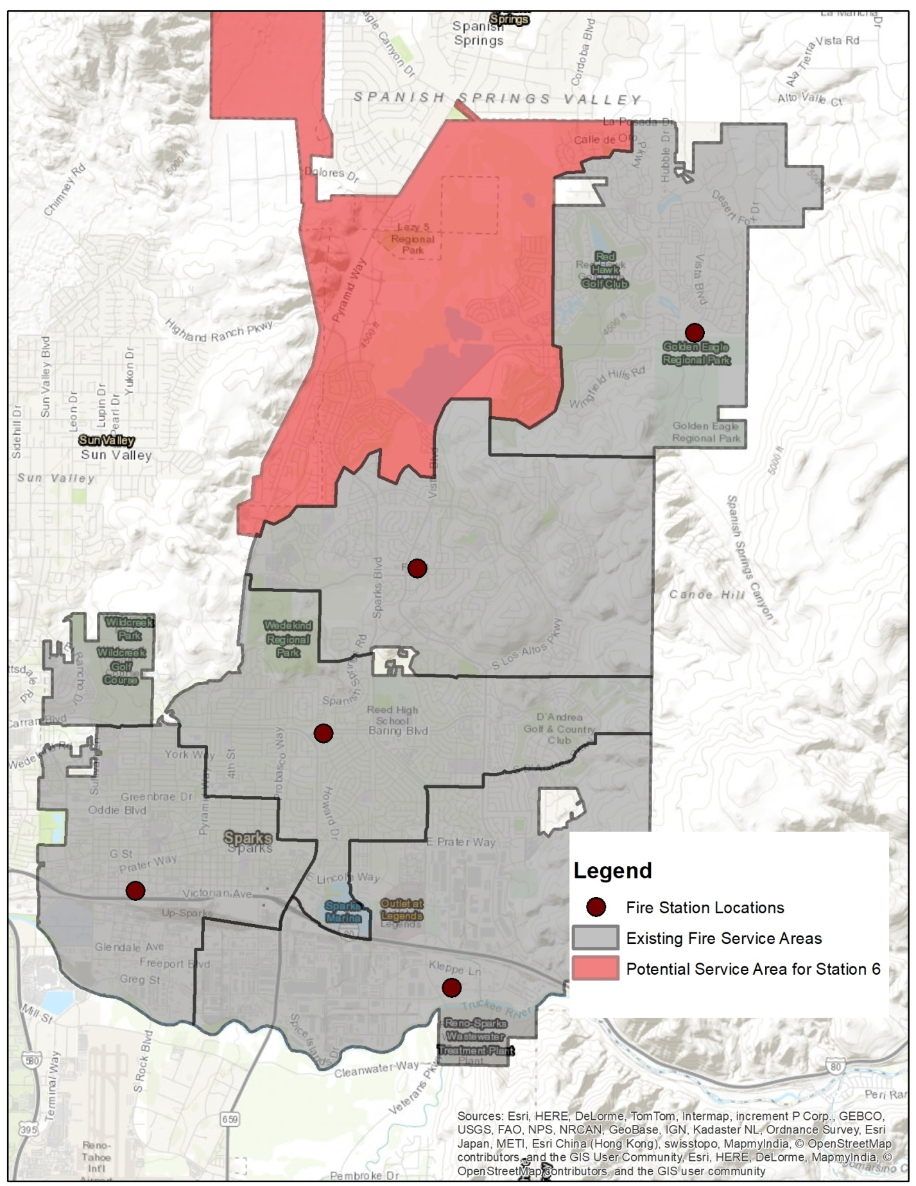

#### Road Fund

Expenditures for the Road Fund are estimated based on the current average annual expenditure per square foot of pavement maintained by the City. The annual maintenance and replacement cost per square foot of pavement within the City is $0.104 per square foot. The location of the City’s fleet and roadway maintenance yards are in the southern portion of the City. This location makes service to areas of the northern portion of the City more expensive as the crew and materials need to be transported longer distances to make repairs. Factors for various portions of the City for road maintenance costs were developed based on average drive time. Portions of the City within the McCarren Loop (area 1) have the lowest cost, while areas in the north portion of the city (area 3) have the highest. The service areas are shown in **Figure 2**.The service areas cost multipliers are shown in **Table 4.** The Road Fund annual cost factors are provided in **Table 5**. The factors are split between factors based on the number of pavement square feet for local roads and the linear feet of local roads.

Table 4

Road Fund Cost Multiplier by Area



Table 5

Road Fund Cost Factors



Figure 2

Road Fund Service Areas

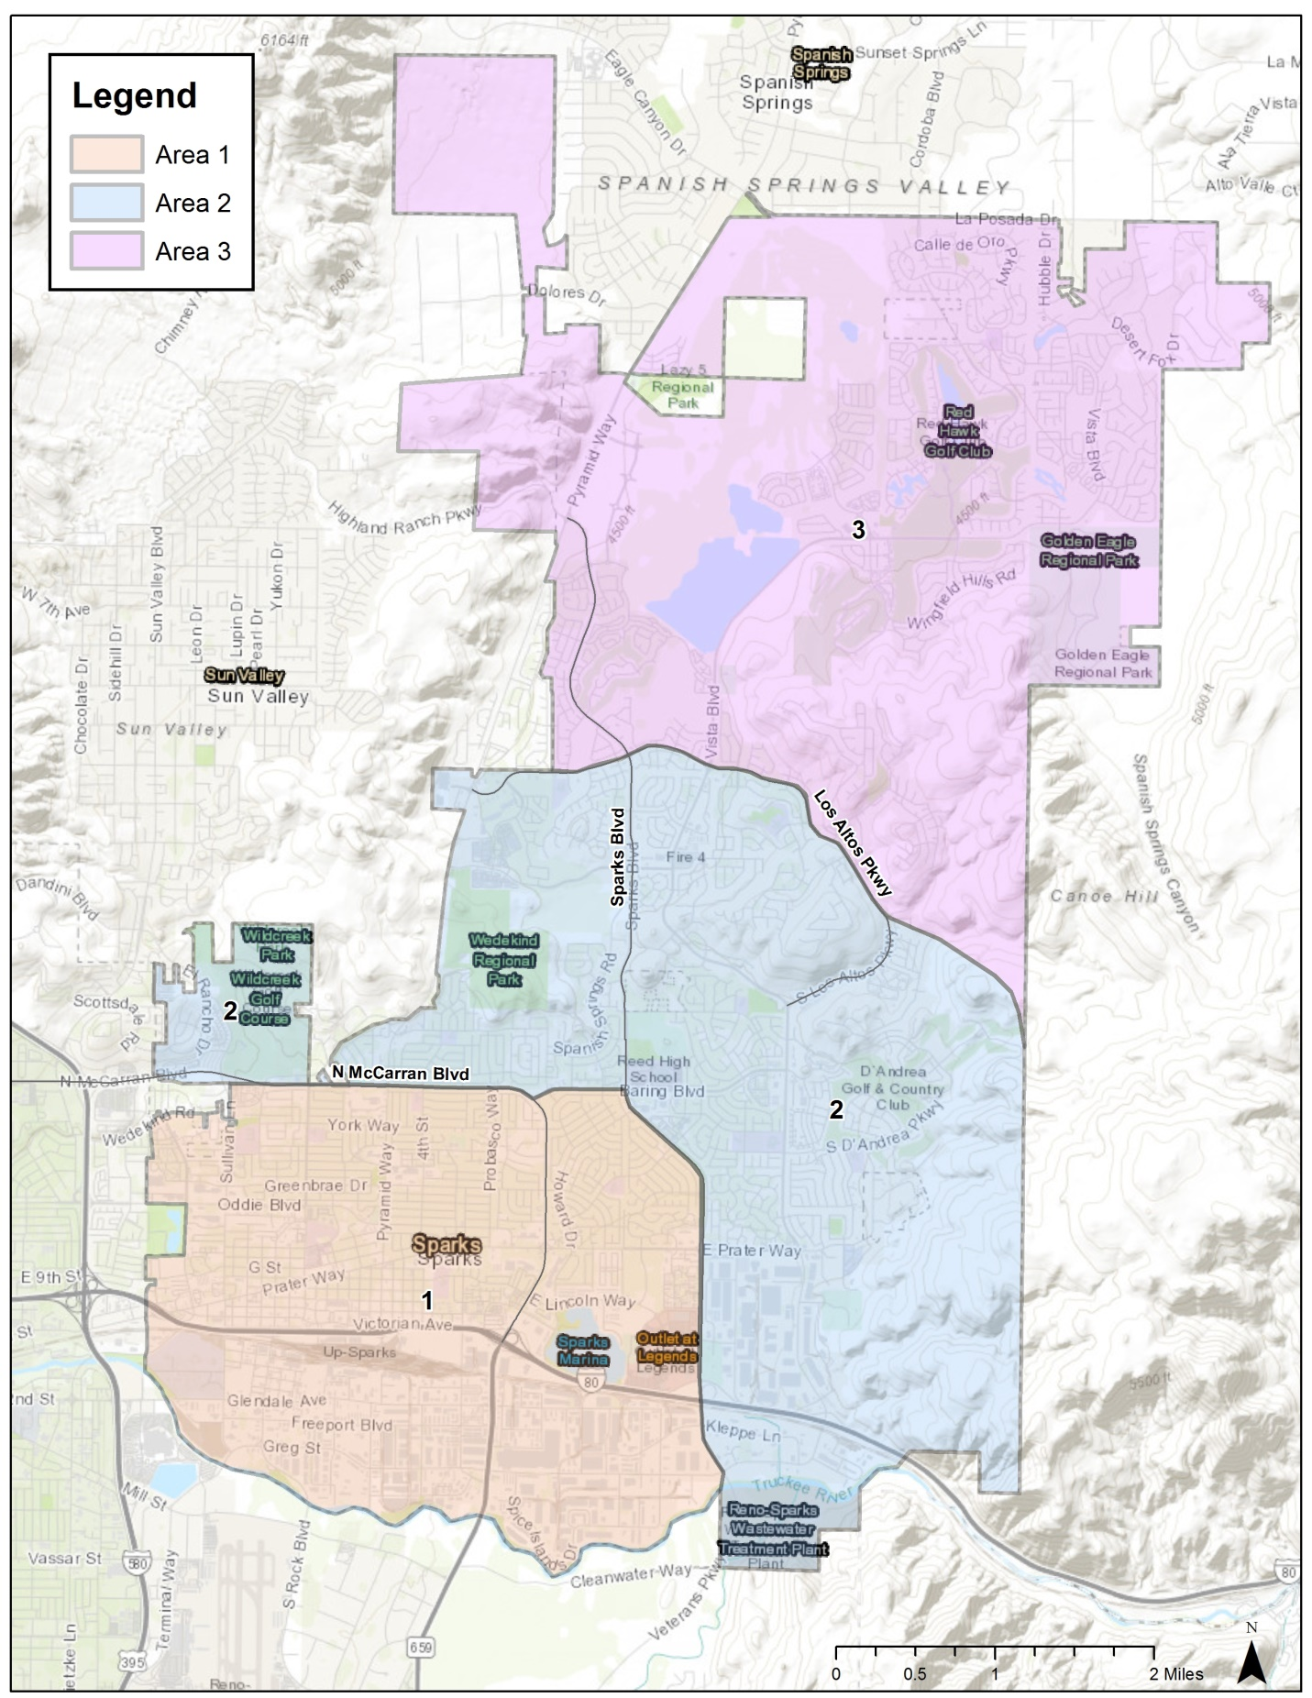

1. In order to avoid overstating expenditures, revenues the City receives from the Base Distribution are subtracted from annual expenditures based on a pro rata share of each expenditure item’s proportion of the total.